Lab 06 Report:
Name : Amit Singh
Roll no. CS-23411035
GitHub repository link: https://github.com/Amit769/lab06-node-fullstack-skeleton/tree/main
https://github.com/Amit769/lab06-node-fullstack-skeleton.git

Node.js Backend with GitHub Integration (Fullstack Skeleton)
1. Introduction
This project focuses on creating a basic full-stack skeleton structure consisting of separate backend/ and frontend/ directories. The primary objective is to develop a working Node.js backend using Express.js and push the complete project to GitHub while maintaining proper repository structure and version control practices.
This lab helps in understanding backend server creation, route handling, project structuring, and Git workflow.

2. Project Structure
The project follows a strict folder hierarchy:
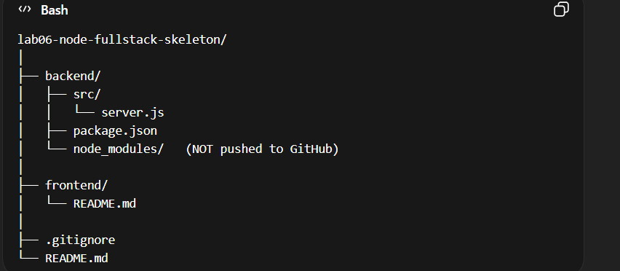
3. Backend Implementation
The backend was developed using:
- Node.js
- Express.js
- Port: 3000
The server includes three routes:
- / – Displays a success message.
- /about – Displays student details.
- /health – Returns JSON status { status: "ok" }.

4. Git and GitHub Integration
Version control was implemented using Git. The following steps were performed:
- Initialized Git repository
- Added project files
- Created meaningful commit message
- Created GitHub repository
- Pushed project to GitHub using:

Program snippets:
